**QGIS and Groundwater Vistas: Developing a Model From Scratch**

**Introduction**

The purpose of this exercise is to show you how to use QGIS when building numerical groundwater models using Groundwater Vistas (GWVs). You will learn different sources for obtaining data, how to create shapefiles meaningful to a groundwater-surface-water model, and how to import these shapefiles into GWVs. You will need to have QGIS with GRASS installed. You can download it here: <https://qgis.org/en/site/forusers/download.html>. Use the OSGeo4W Network Installer if you are using Windows.

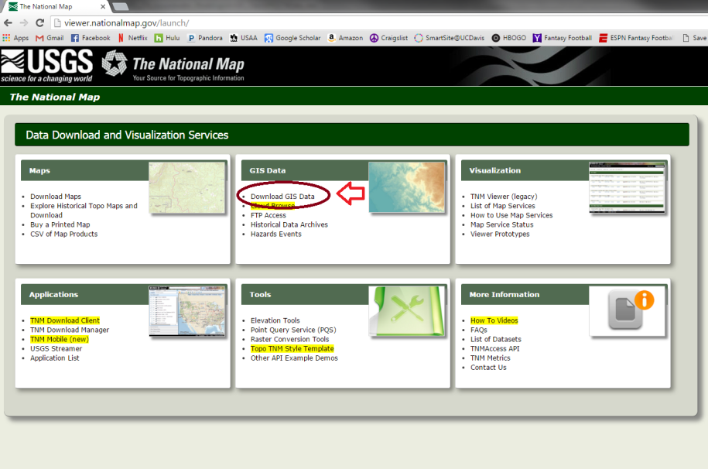**Exercise 1 – Extract Elevation Data**

Go to <http://viewer.nationalmap.gov/> and click on

the Download GIS Data link.

Select the Elevation Products (3DEP) box, then 1/3

arc-second DEM (DEM = digital elevation model). This corresponds to elevation data that has about 10m spatial resolution. Zoom to the Scott Valley in Northern California. The DEM is available as a georeferenced .tif file.

To select data to download, click on the button that has a little square on the left side of the map window and draw a box around the Scott Valley. Make sure it is large enough that you get all the flat areas of the valley. It is better to make your box a little bigger so you don’t have to come back and download data again later. After you have defined the area you want data for, select the Find Products button. Data from selected categories that fall into your window are displayed and can be downloaded.

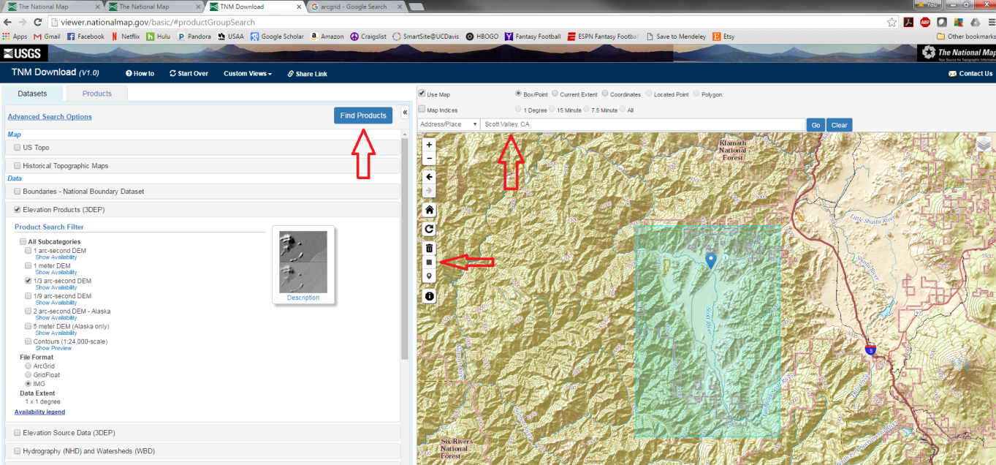

DEM files can be rather large, so we have already downloaded the data for you.

1) Open up a new QGIS project and save it as “HYD274_Model_Data_*YourLastName*”

2) Add **USGS_13_n42w123.tif** to the map.

The projection for this raster is the geographic coordinate system **GCS_North_American_1938**. We want to change to a Universal Transverse Mercator (UTM) coordinate system because it is much easier to work with. Use **NAD 83 UTM Zone 10N**.

**Raster🡪Projections🡪Warp (reproject)**

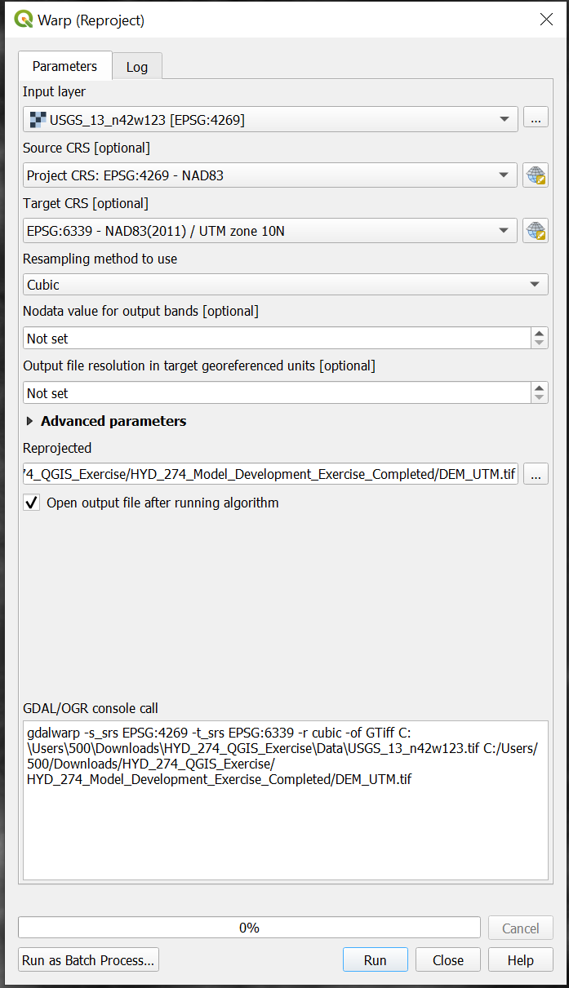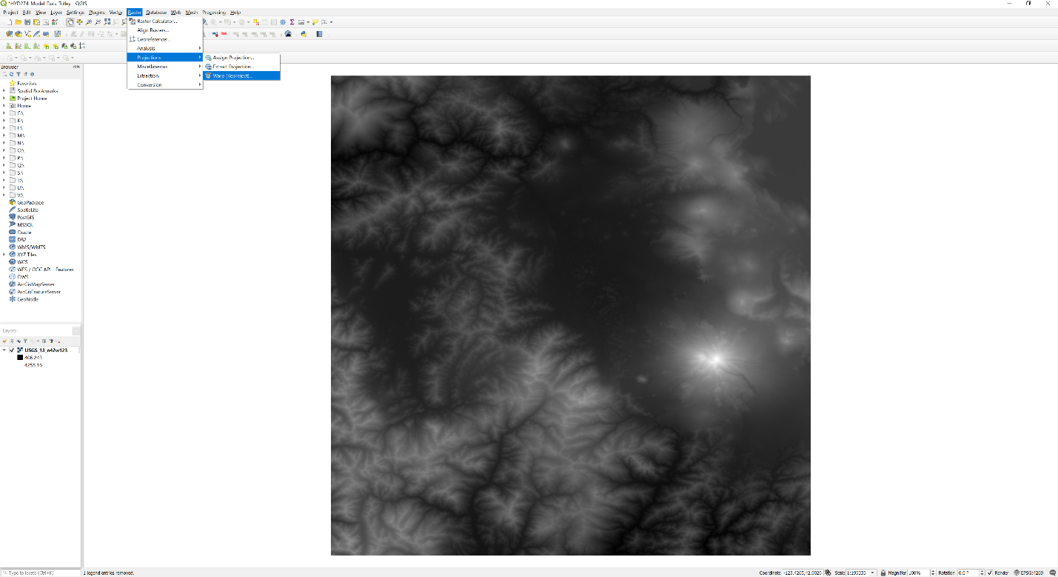

**IMPORTANT: Be sure to use Cubic resampling or else any hillshades you make with the reprojected raster will have strange linear artifacts.**

3) Notice that our DEM covers a much larger area than the Scott Valley. Working with data sets that extend beyond our potential modeling domain makes processing and drawing times much longer, so let’s clip out a portion that is more manageable. First, we need to create a new shapefile that will contain a rectangle defining the area we want to clip the DEM data to. Select the “**New Layer Shapefile...**”

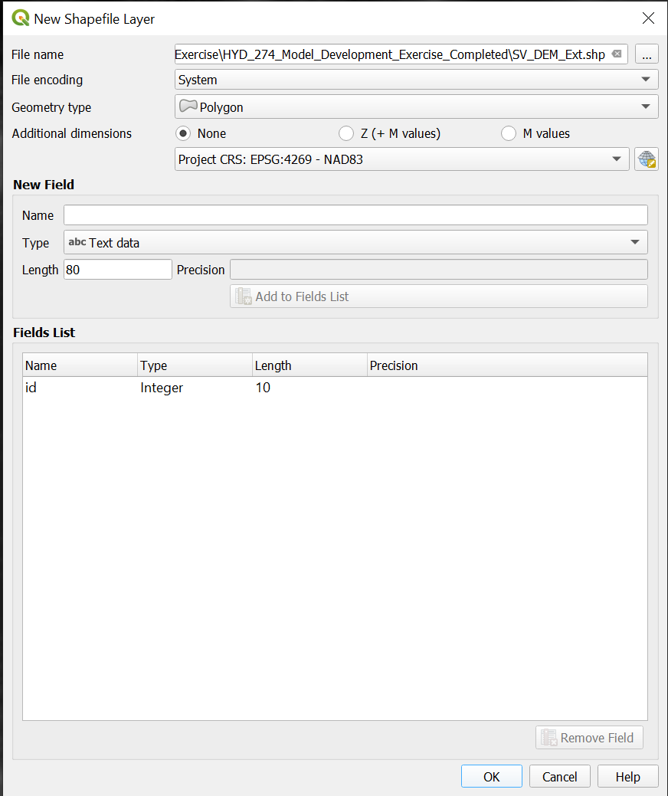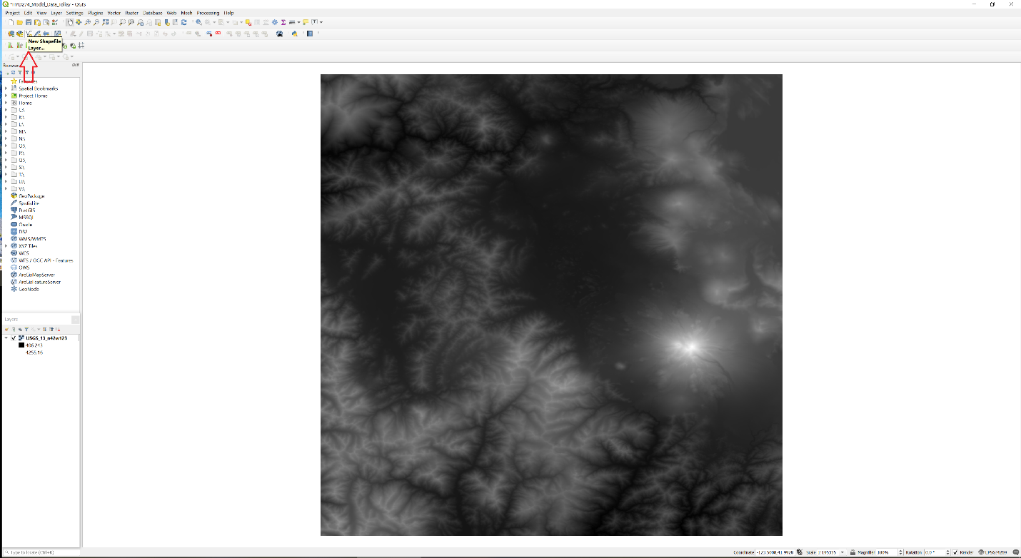

File name: **SV_DEM_ext.shp**

File encoding: **System**

Geometry type: **Polygon**

Additional dimensions: **none**

Project CRS: **EPSG:6339 NAD83(2011) / UTM zone 10N**

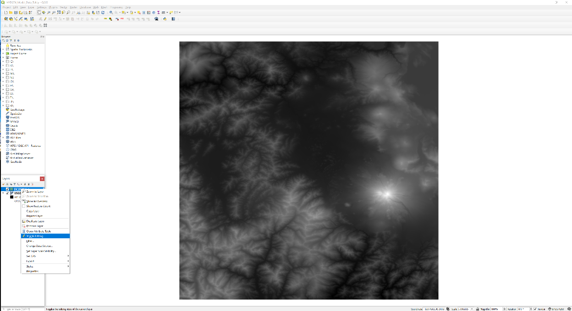4) Now we have a polygon shapefile, but there is no data associated with it. We are going to draw a rectangle that we will use to cut out some of the DEM data. Right click on the **SV_DEM_ext** shapefile in the **Layers Panel** and then select **Toggle Editing**.

Select the **Add Rectangle from Extent** tool from the **Shape Digitizing Toolbar**. You will notice the cursor changes to a crosshair when you move it over the map. This means it is ready to start drawing your feature. Draw the rectangle so that it covers the Scott Valley. It’s better to have a little larger rectangle than to make the clipping area too small so that you have to go back later because you missed some important area. You can also have the rectangle extend past the left edge of the DEM so you don’t miss anything on that edge. Left click once to start drawing the rectangle and drag your mouse to the appropriate area.

Right click to finish drawing the rectangle. It will then ask you for a feature attribute. Just enter any integer (1 works perfectly fine).

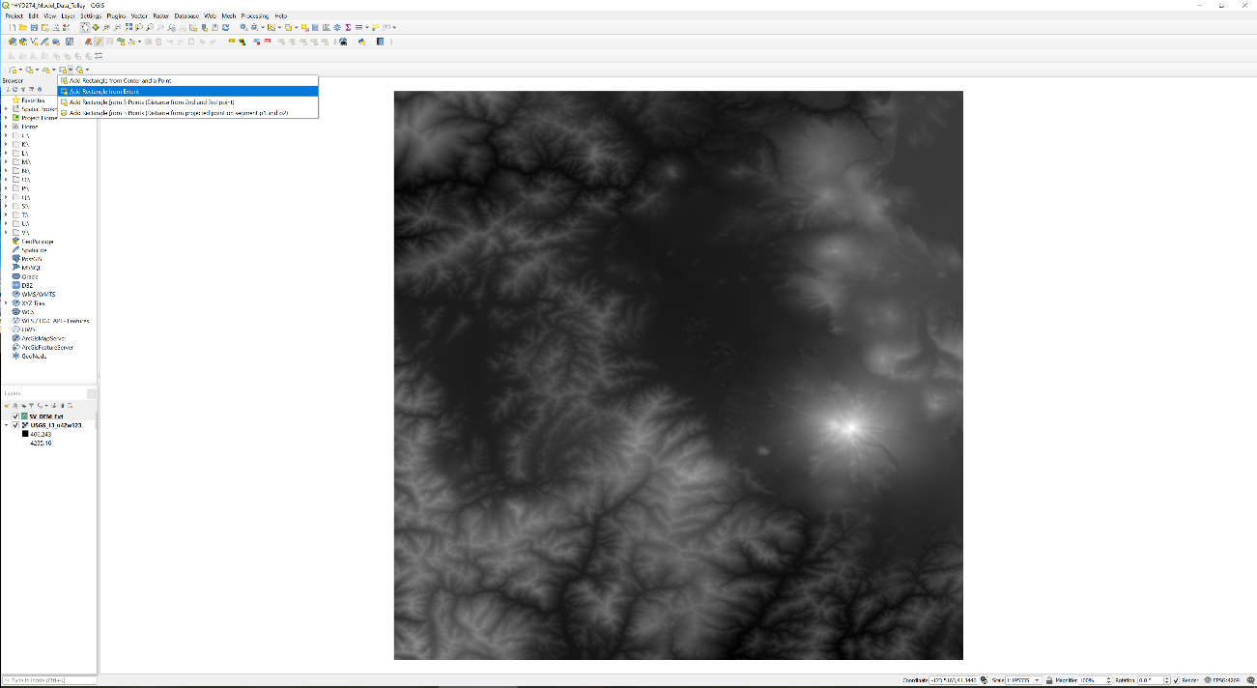

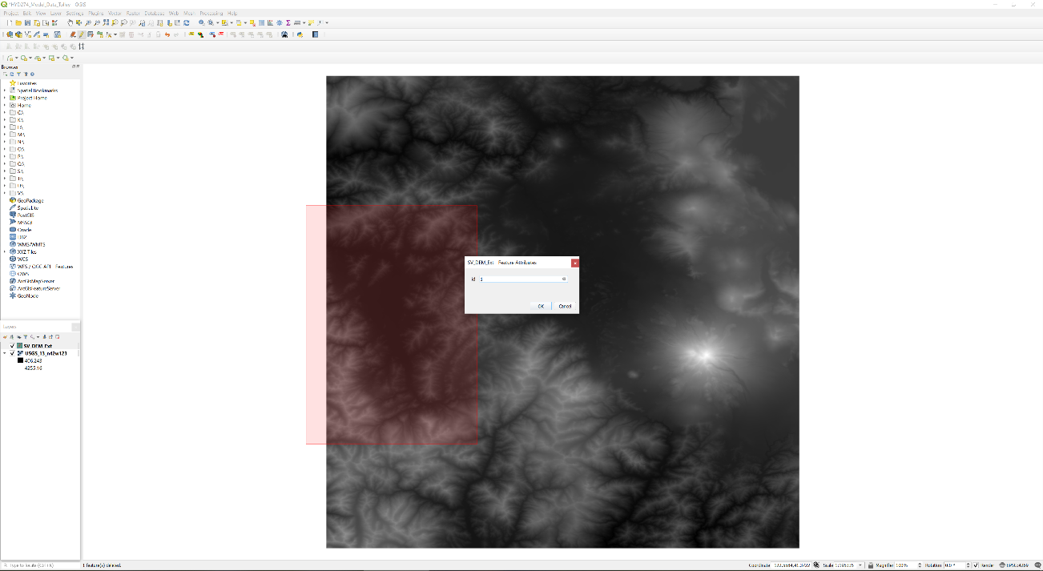

5) Right click on the **SV_DEM_ext** shapefile in the **Layers Panel** and then select **Toggle Editing** to end the editing session. Save your edits!

6) Next we want to use our rectangle to clip the DEM data using the **Clip Raster by Mask Layer** tool under the **Raster** menu. Save the Output at DEM_UTM_clip.tif

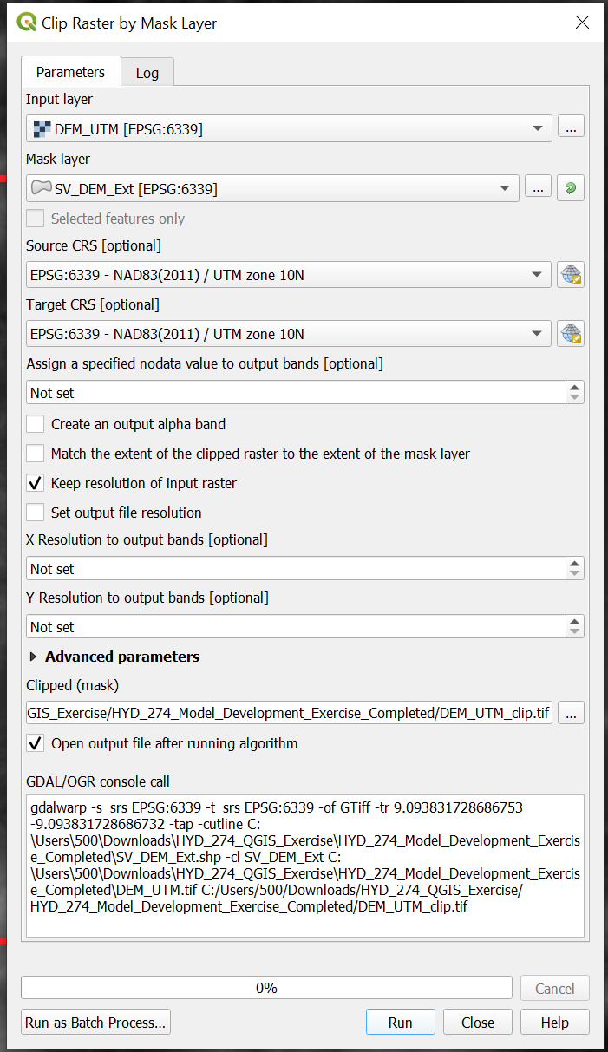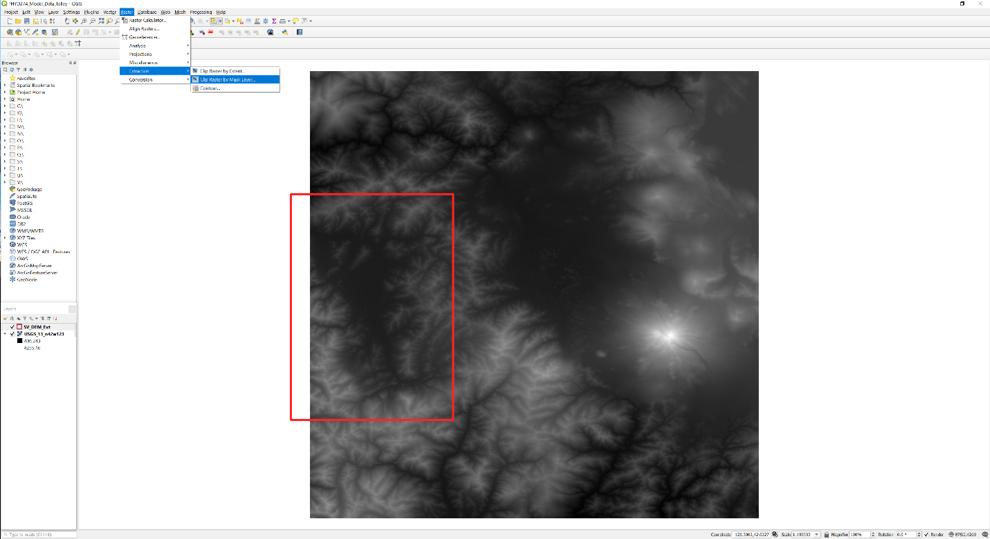

Input layer: **DEM_UTM**

Input raster or feature mask data: **SV_DEM_ext**

Source CRS: **EPSG:6339 NAD83(2011) / UTM zone 10N**

Target CRS: **EPSG:6339 NAD83(2011) / UTM zone 10N**

We have now extracted the DEM data contained within the rectangle we drew earlier. Do you notice anything different about the values for this new raster?

8) We now have a general model domain with elevation data. We need to define the area where our flow cells will be active. The Scott Valley is an alluvial groundwater basin surrounded by relatively impermeable rock, so we want our flow cells to coincide with the more permeable alluvium. The alluvium tends to be deposited on flat surfaces, so let’s start there. First, we need to make a new raster using the **Slope** tool (**Raster🡪Analysis🡪Slope**).

Input layer: **DEM_UTM_clip**

Output measurement: **DEGREE**

Ratio of vertical units to horizontal: **1**

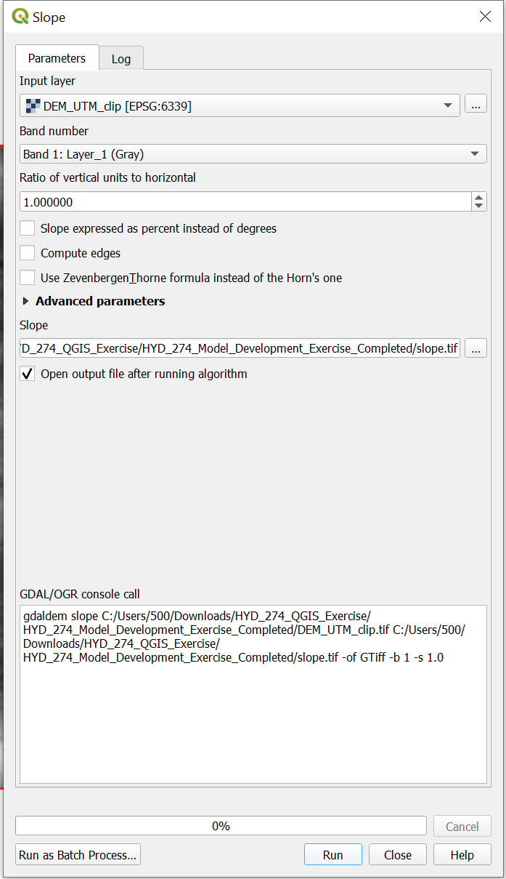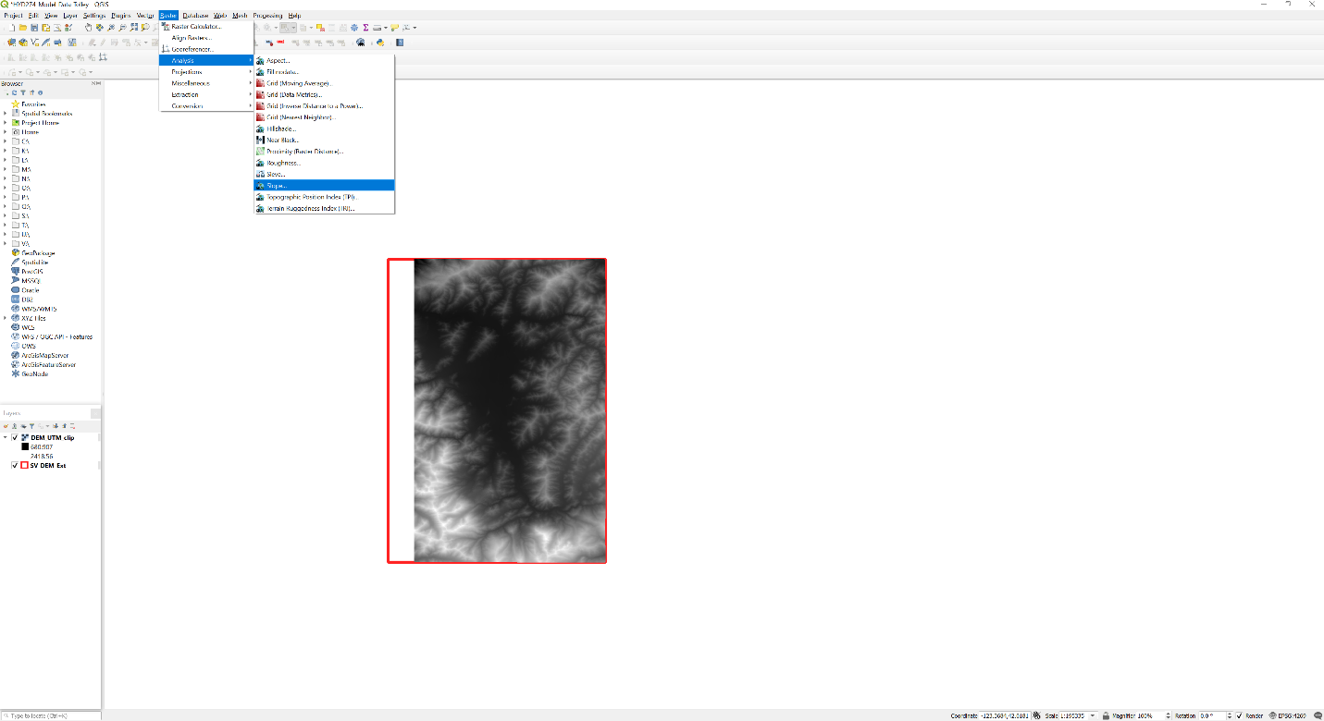

9) Now we want to contour the slope raster we just made using the **Contour** tool (**Raster Extraction🡪Contour**).

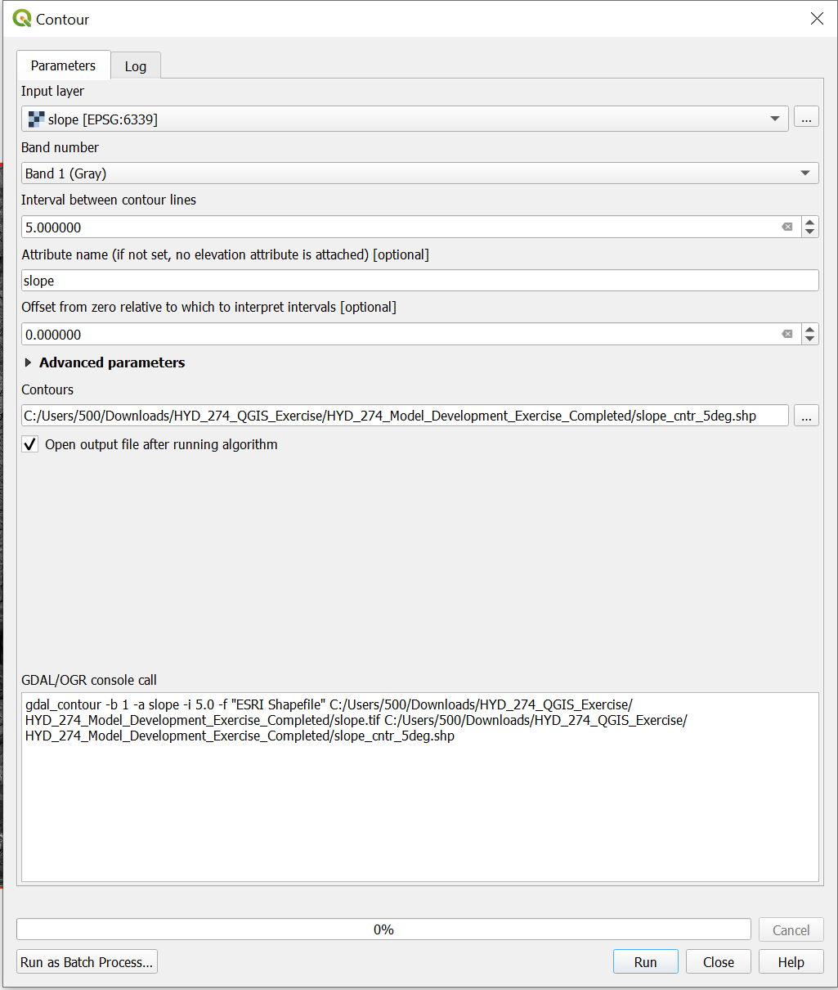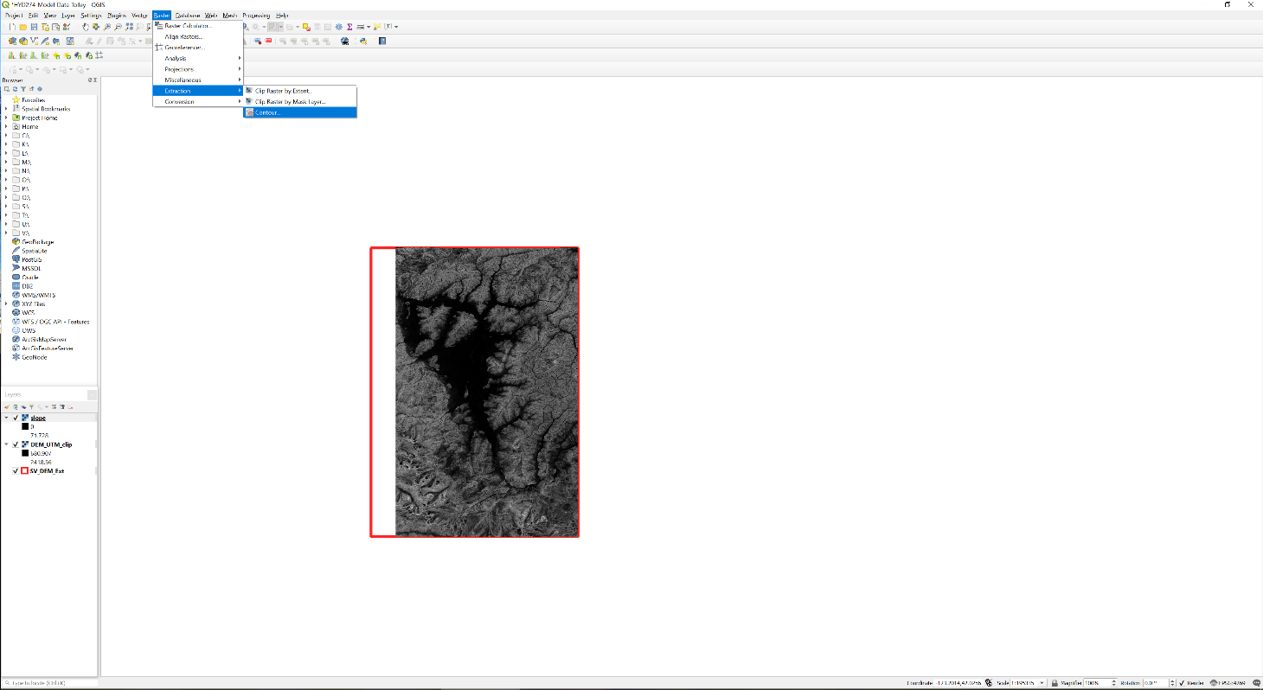

Input layer: **slope**

Interval between contour lines: **5**

attribute name: **slope**

Offset from zero from which to interpret intervals: **0**

10) We want to extract two lines from the contour map we just made, one for the margin of the valley and the other that outlines Chaparral Hill (you can select additional contours that define outcrops within the valley if you wish). Zoom into the west side of the Scott Valley so you can see the individual contour lines. Use the **Identify** tool to make sure you know which line is the 5 degree, then use the **Select Features** tool to select that contour. Zoom out (right click on the layer in the **Layers** pane and click on **Zoom to Layer**), then zoom into the margin of Chaparral Hill (see screen shot below). Hold down the Shift key and select the 5 degree contour surrounding Chaparral Hill. You should have two polylines selected now. Right click on **slope_cntr_5deg** in the **Layers** pane and select **Export🡪Save Selected Features As...**

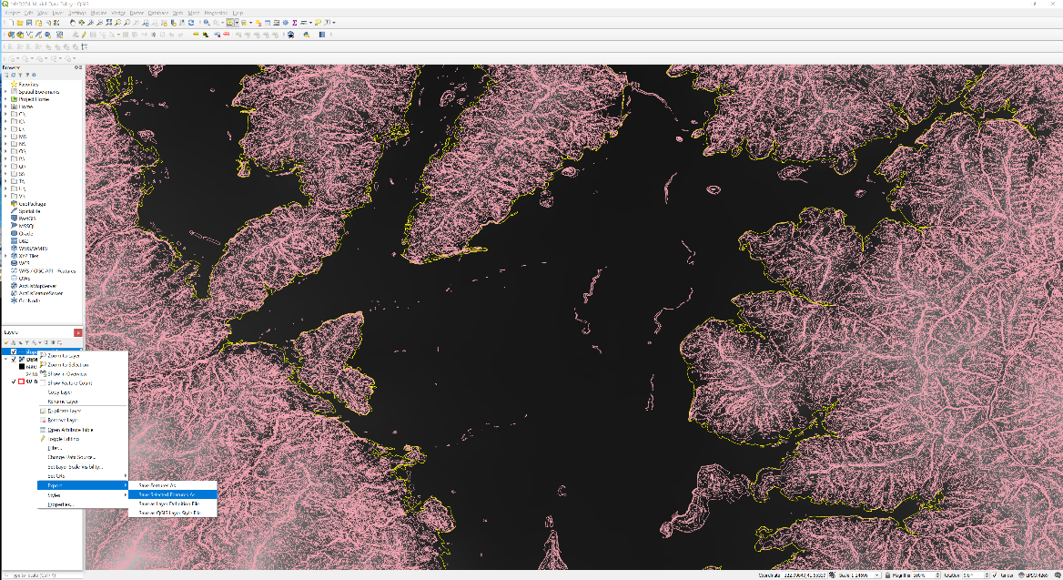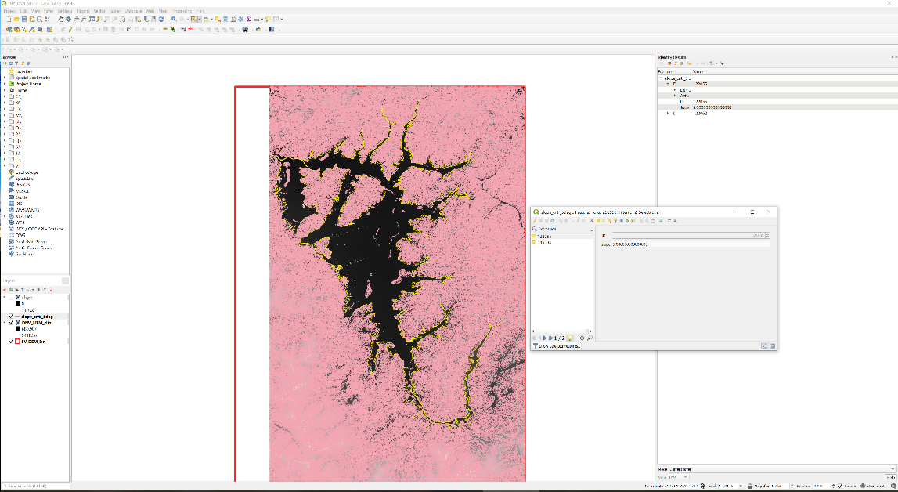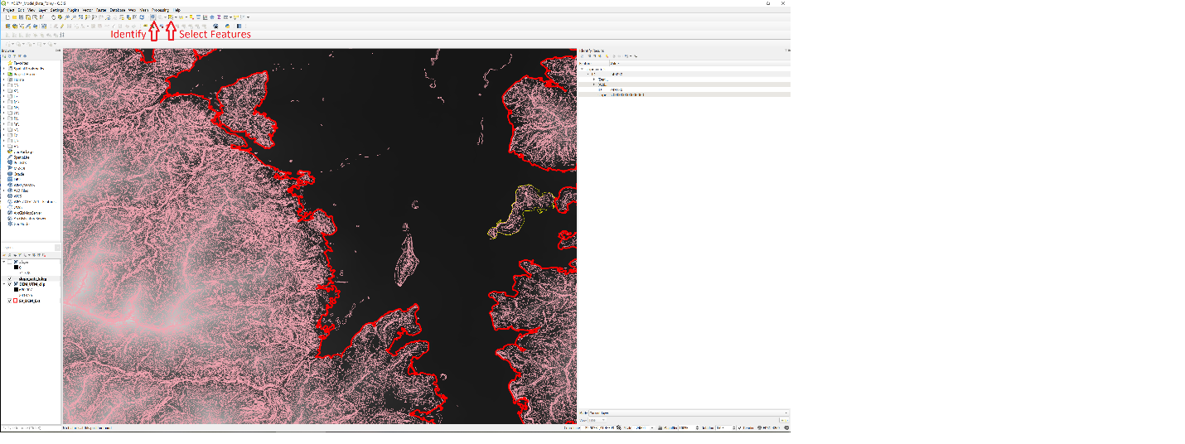

Format: **ESRI Shapefile**

File name: **5deg_cntr.shp**

CRS: **EPSG:6339 NAD83(2011) / UTM zone 10N**

Make sure the box to add the saved file to the map is checked.

11) Now we need to convert these lines into polygons so we can do other things like clip polygons, mask rasters, and make pretty maps. The first thing we need to do is join the two lines that outline the entire basin. We’ll do that by dissolving the two features into a single feature.

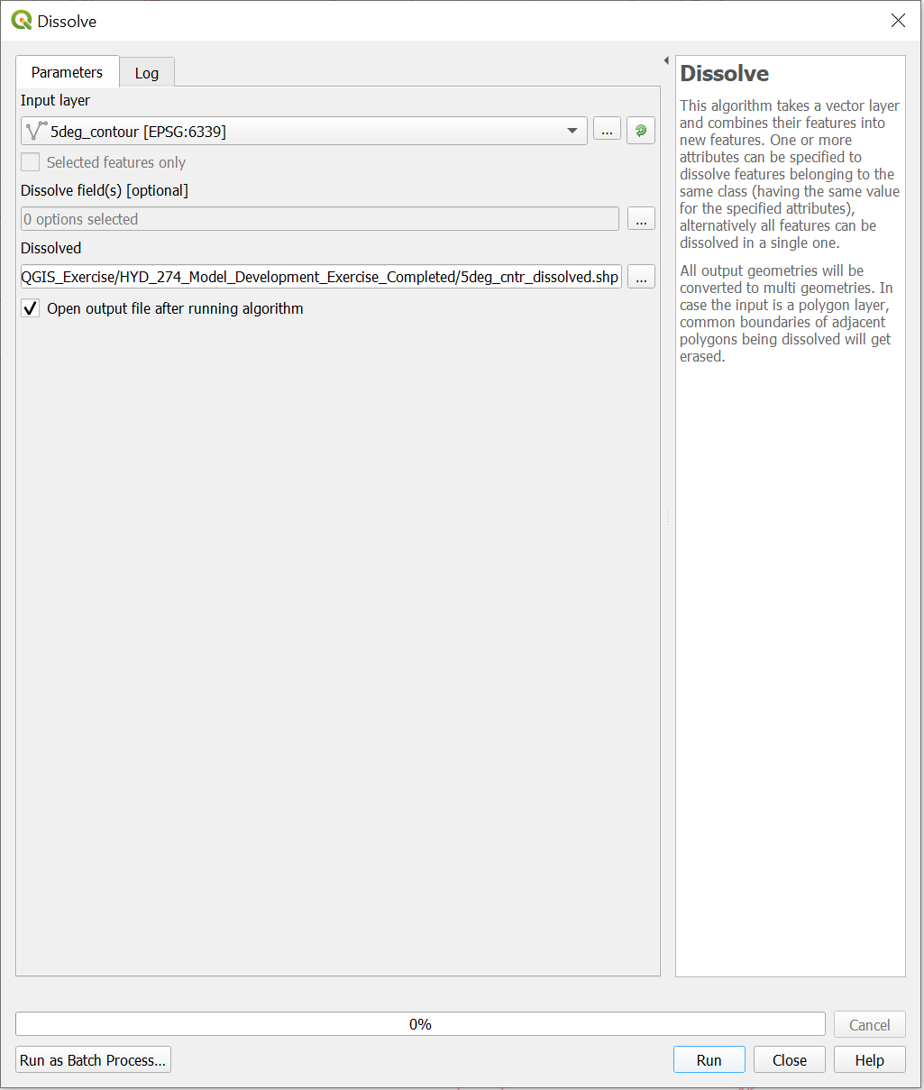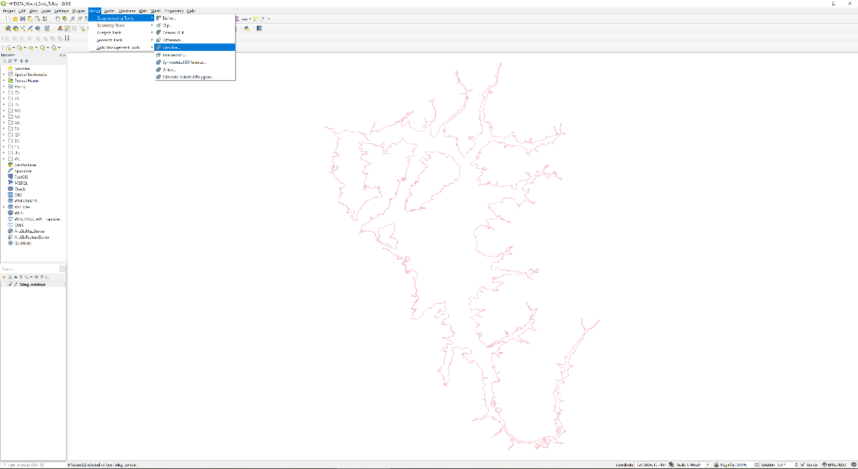

input layer: **5deg_contour**

dissolved: **5deg_contour_dissolved**

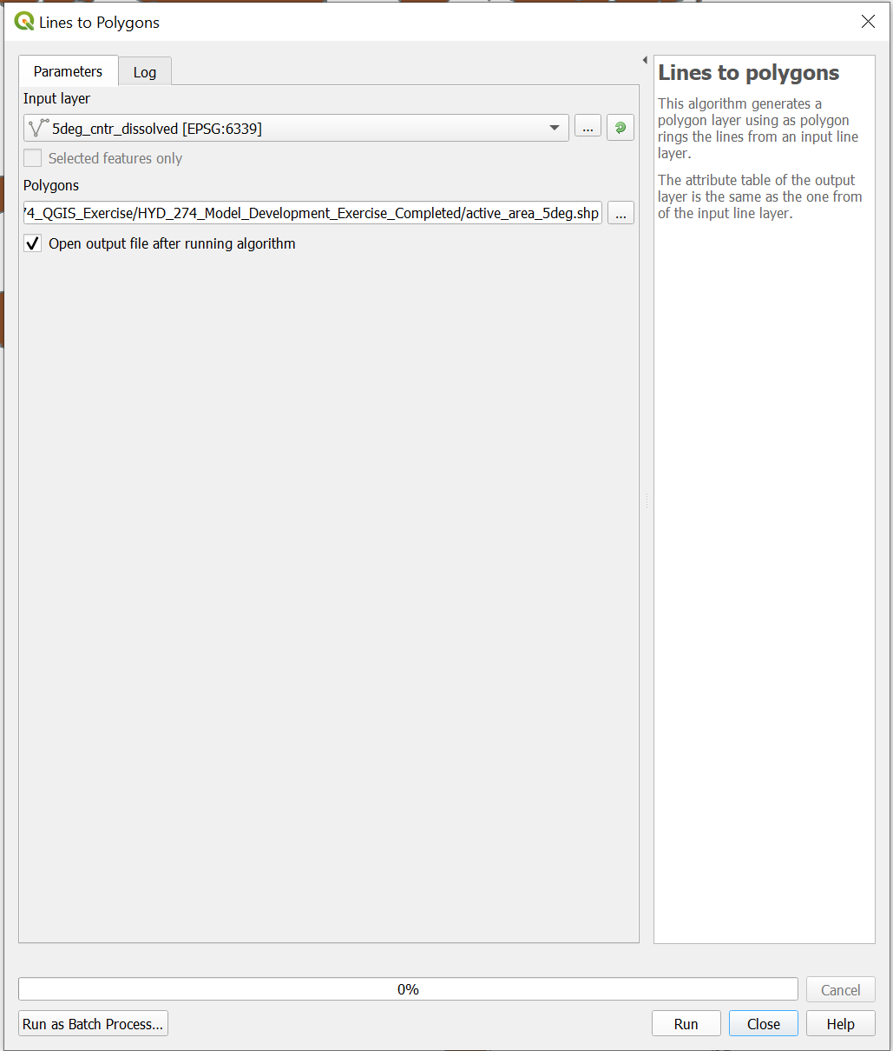Convert these lines to polygons using **Vector🡪Lines to Polygons...** 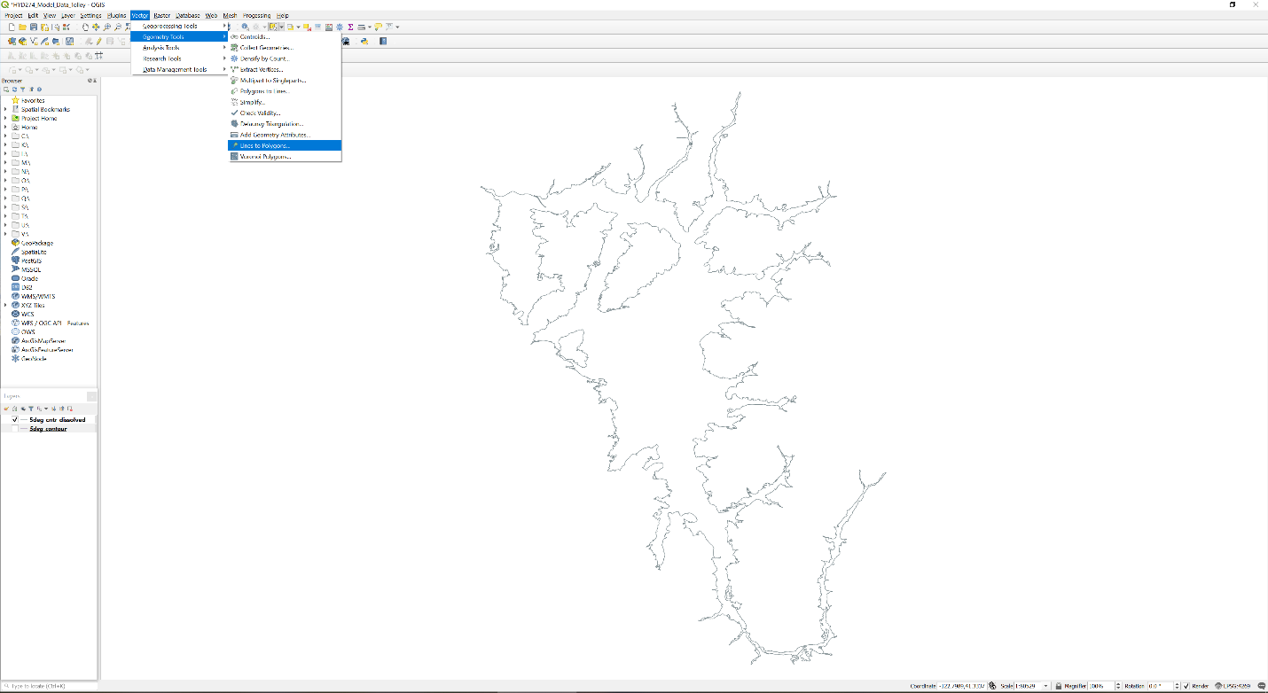

Input layer: **5deg_cntr_dissolved**

Polygons: **active_area_5deg.shp**

12) If you open the attribute table for **Active_Area_Polygon_5deg**, you will notice that we now have many different polygons in this shapefile. We want a single polygon to import into GWV, so we need to modify it a little. Open an editing session (see step 4) and modify the polygon in the following ways:

i) delete the polygon over Chaparral Hill and any other outcrops you selected in the valley

ii) delete any random polygons that are not attached to the valley

iii) merge polygons located within the valley (select features then **Editor🡪Merge**).

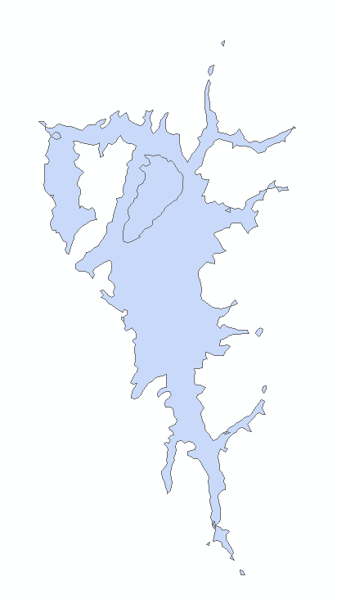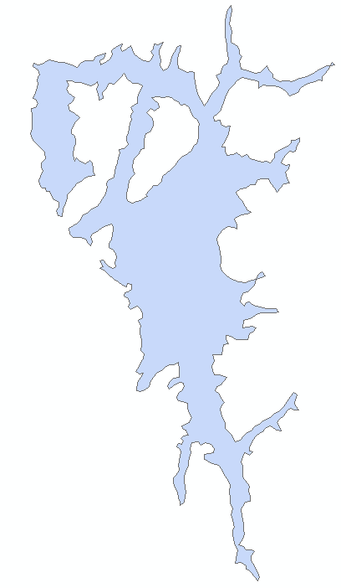

After

Before

13) We finally have a (rough) active area for our model. Now let’s work on getting the stream network. Although there are about 10 tributaries to the Scott River, for the sake of time we are only going to represent 1 (Kidder Creek).

Add the **NHDFlowline** shapefile (**NHD21205_CA.gdb🡪Hydrography🡪NHDFlowline**) to the map. Also add the unit 8 sub-watershed delineations to the map (**NHD21205_CA.gdb🡪WBD🡪WBDHU8**). Select the Scott sub-watershed and export it to its own shapefile (**SV_Watershed.shp**).

Use the **Clip** tool (**Analysis🡪Extract🡪Clip**) to clip this data to the **SV_Watershed** shapefile you made earlier.

Input Features: **NHDFlowline**

Clip Features: **SV_Watershed**

Output Feature Class: **NHDFlowline_Clip**

14) Open an editing session for **NHDFlowline_Clip** and delete everything except for the Scott River and Kidder Creek. The easiest way to do this is to open the attribute table and sort the features by name (double click on the **GNIS_name** header to sort it alphabetically). You can select multiple features at once by using shift-select, similar to Excel. You might have a little bit of the Scott River near the top left corner of the rectangle (see image below). Go ahead and delete that too, it will make your life easier later. Save your edits and close the editing session when you are done.

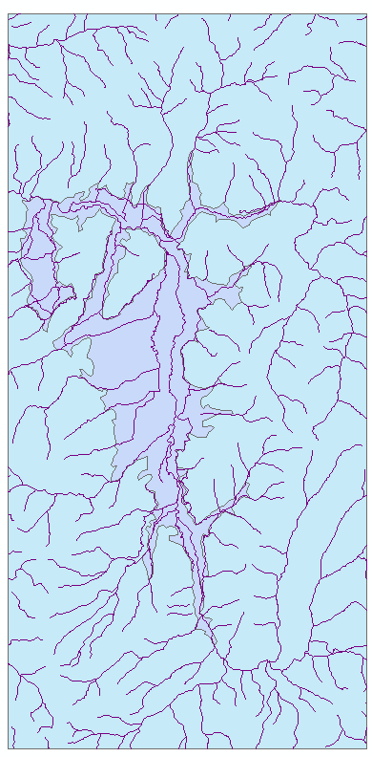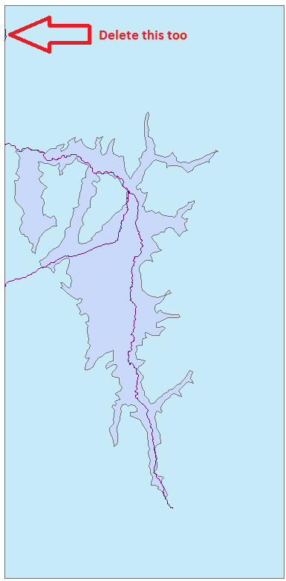

After

Before

15) If you zoom in, you can see that our polyline for the Scott River actually crosses the active area boundary. This is a problem because when we import the shapefile into GWV, our river will be discontinuous. Either we need to extend our model boundary, or change the location of the river. This can be quite a tedious task so we aren’t going to do it today, just be aware of it in the future. Add **SFR_Segments.shp** to the map. The stream channel has been adjusted for you so that it doesn’t cross into a no-flow cell.

Open the attribute table and notice that we have three separate features and several fields have been added as well. Each feature is a segment, which will be made of many reaches once we import it into GWV. Whenever two segments come together, a new segment is formed (refer to the SFR manual for a more detailed description of segments and reaches). When we import shapefiles into GWV, we need to specify values for both ends of the polyline (note that polylines have a direction, which can be determined by changing the symbology of the polyline shapefile to **Arrow at End**. Stream polylines should ALWAYS go from upstream to downstream). GWV will automatically linearly interpolate between the two end points if you wish, or you can enter the same value in for both.

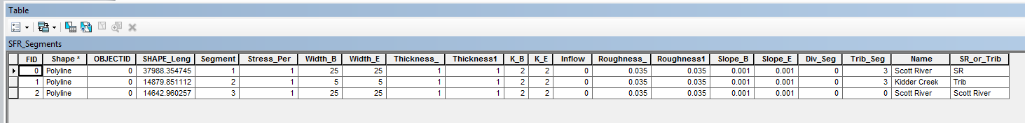

16) Now we have the location of our streams, but we are still missing some vitally important data: the streambed elevations. We could do a linear interpolation from the beginning to the end of each segment in GWV, but interactions between groundwater and surface water in the model are highly dependent on the elevation of the streambed so a linear interpolation is a poor assumption. Since we have a DEM of the area (or possibly LIDAR data of the streambed itself if you are lucky), let’s extract the elevation for each reach. We’ll also resample the DEM data within our grid cells to get our top layer elevation a little bit later.

First, we need to know where our reach segments are going to be located, and therefore we need our model grid. Obviously, the number of cells that we have is going to influence our results and run time. So we need to ask ourselves: how big is our domain? An easy way to find out is to open the **Layer Properties** for your **Active_Area_Polygon_5deg** shapefile and click to the **Source** tab. At the top of this tab is the spatial extent of the shapefile. It looks like we have ~38,500 m in the y direction, and ~21,000 m in the x direction. If we have grid cells that are 100 m by 100 m, that corresponds to 385 rows and 210 columns.

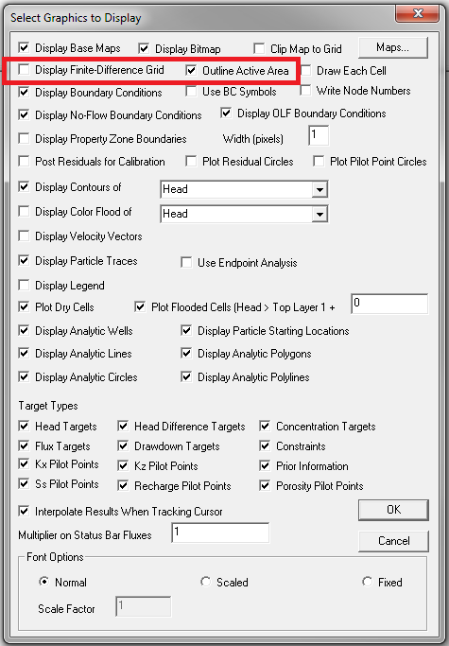Open GWV and start a new model with 385 rows, 210 columns, and 2 layers. Change the World Coordinates of Model Origin to the low left corner of the active model area, rounded down to the nearest integer (right click on layer in ArcMap and go to **Layer Properties🡪 Source**). Leave everything else as default, we’ll change it all later. Turn off the finite difference grid by selecting **Plot🡪What to Display** and then unchecking **Display Finite-Difference Grid**. You can check **Outline Active Area** if you wish, click OK to close the window.

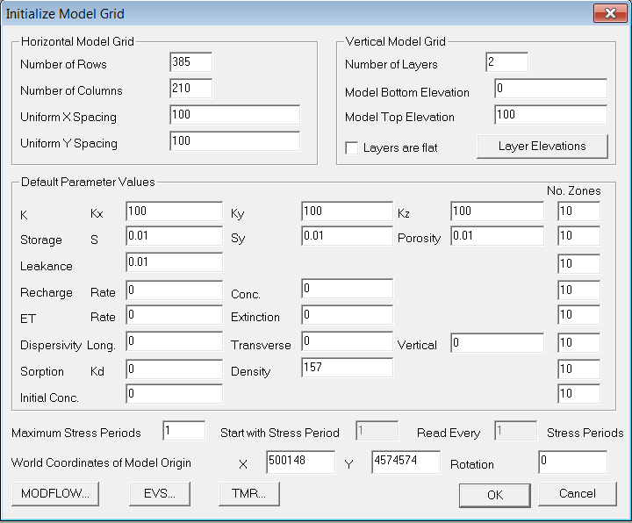

17) Next we will define the coordinate system within GWV so we can export shapefiles to ArcMap. Select **Edit🡪GIS Options…** and find a projection file (.prj) that you know is in **NAD 83 UTM Zone 10N** coordinates. Every shapefile has a .prj file associated with it, so you just need to go to a folder where you know a shapefile projected in **NAD 83 UTM Zone 10N** exists (for example, **SFR_Segments_GWV_Input.shp**).

18) There are two ways that you can use GIS data in GWV. The first way is to just add the shapefile as an overlay to view and/or manually digitize features. To do this, select **File🡪Map🡪Shapefile…** and choose the shapefile that you want to add. Let’s add **Active_Area_5deg.shp** as an overlay so we can see how it works. A second dialog pops up asking for a .map file. This is created by GWV, so just name it the same as the shapefile or feel free to create a new name. You can add many different shapefile overlays, and can modify which ones are displayed at any given time by going to **Plot🡪Map Overlays…**

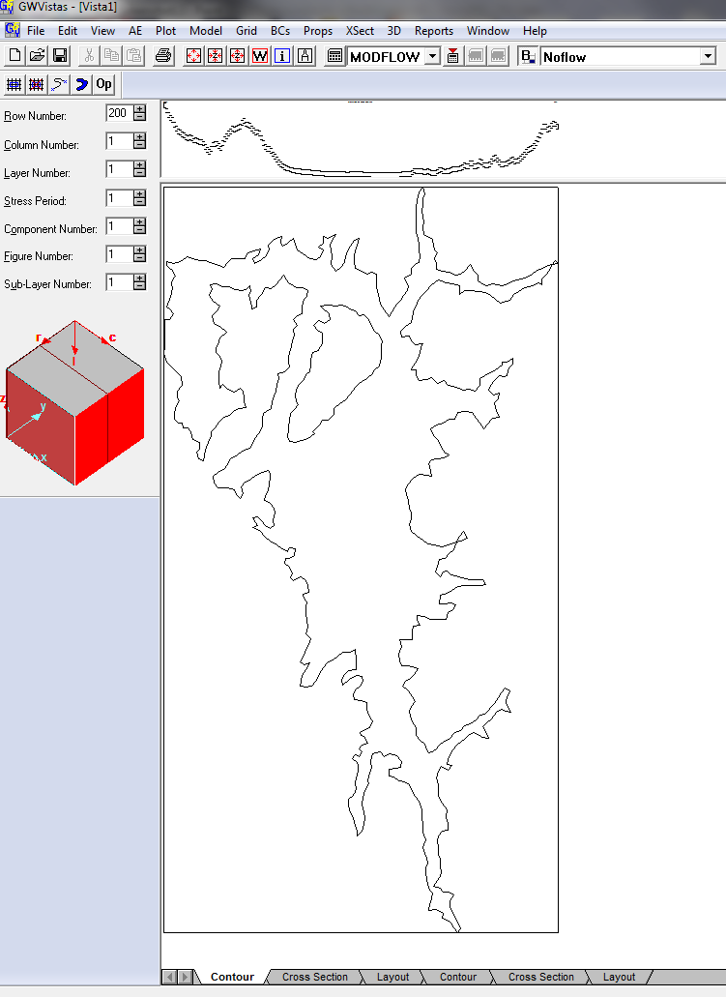

The second (and more elegant) way to use GIS data in GWV is to actually import the shapefiles to define property zones, boundary conditions, and analytic elements. This is what we are going to do in a bit.

19) Lets export our Model Grid so we can bring it into ArcMap and finish up our stream network. Select **Grid🡪Export🡪Shapefile…** and save the shapefile as **Model_Grid**. Select Yes when asked to export the grid as polygons, then add this shapefile to your map.

20) GWV will cut our stream segments into smaller pieces (known as reaches) wherever they intersect our model grid lines. Once we import our stream into GWV, the reaches are associated with a model node. If we were to export our reaches and import them back into ArcMap, the spatial resolution would be much coarser as you can see in the image below.

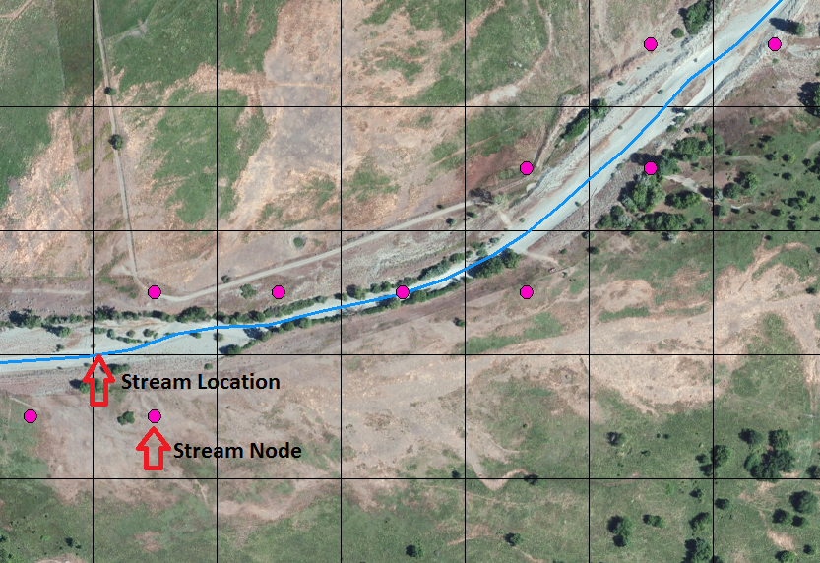

Since our DEM has 10 m resolution, if we extracted values at the model nodes we would be overestimating the elevation of the streambed. Instead, let’s extract the elevation from the DEM for each reach and specify it when we add our stream network into GWV.

Use the **Intersect** tool (**Analysis Tools🡪Overlay🡪Intersect**) to split up your stream segments into individual reaches.

Input Features: **SFR_Segments** and **Model_Grid**

Output Feature Class: **SFR_Reaches**

Join Attributes: **ALL**

Since we joined all of the attributes from both shapefiles, our segments now have a row and column associated with them. As you will see later, this will be quite useful.

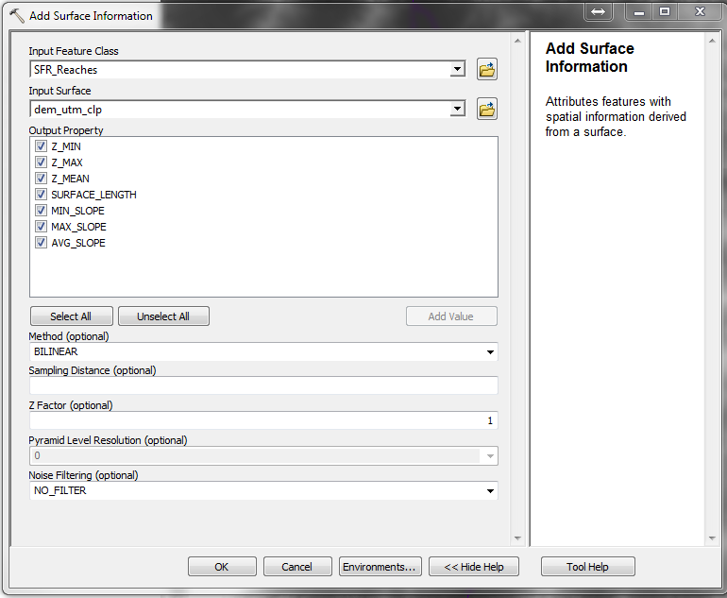21) To extract elevation data for each segment, use the **Add Surface Information** tool (**3D Analyst Tools🡪Functional Surface🡪Add Surface Information**).

Input Feature Class: **SFR_Reaches**

Input Surface**: DEM_utm_clp**

Output Property: **Check all**

Open the attribute table and see what has been added.

22) Now we need to define our hydraulic conductivity zones. There are still many other spatial and temporal datasets that we would need to assemble for a transient model (e.g., ET, recharge, etc.) but unfortunately we don’t have the time to make all of them today.

First, make a copy of your **Active_Area_Polygon_5deg** shapefile. Right click on it in the **Table of Contents** window, select **Data🡪Export Data…,** and export all features. Name it **K_Zones.shp** and add it to the map. Open the attribute table and add a new integer field to the table, named **K_Zone**.

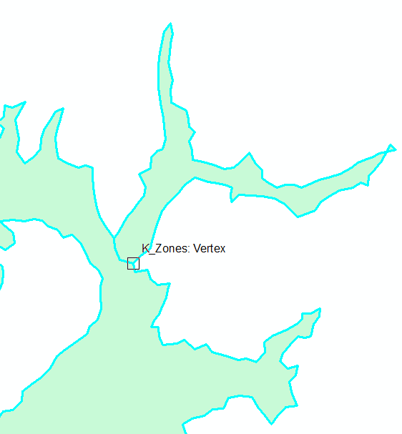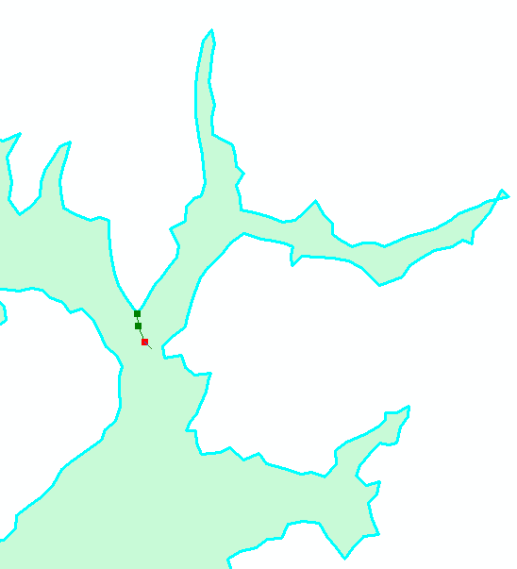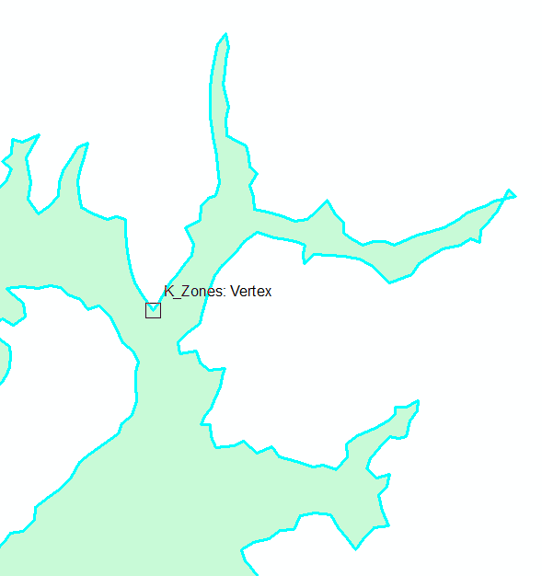Start an editing session. We are going to cut our big polygon into several smaller polygons that will represent different hydraulic conductivity zones. To do this, select the polygon and click on the **Cut Polygons Tool** in the editor toolbar (it looks like a green box with a vertical line through it). Move the cursor so it intersects with one of the edges of the polygon where you want to create a new one (helpful if snapping is turned on), then click within the polygon to make your cut line, and double click to end the cut. For example:

3

1

2

Do this for all of the gulches on the east side of the valley and for Quartz Valley in the Northwest. Don’t forget to change the **K_Zone** value in the attribute table! You should end up with something that looks like this:

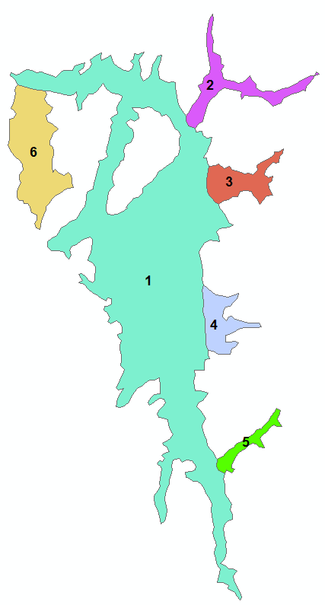

23) Remember when I said we can use shapefiles to define property zones, boundary conditions, and analytic elements? Let’s do that now starting with our no-flow cells. Select **BCs🡪No-Flow**, then **BCs🡪Import🡪Shapefile…** Use the **Active_Area_Polygon_5deg** shapefile, select No when asked to set no-flow cells inside of polygons, and Yes to delete existing boundary conditions (we don’t have any existing conditions so either answer is fine), and set the **Relative Area of Overlap** to **0.2** **BUT DO NOT HIT OK.** Instead hit **Cancel** because importing the no-flow boundaries can take a while (15 min+ if you have a complex polygon). To save time, I did this for you already using the same settings. Go to **BCs🡪Import🡪NoFlow Matrix File…** and choose **No_Flow_Matrix.dat** (you might need to change the filtering option on the bottom right of the explorer window).

22) Now let’s add our hydraulic conductivity zones. Select **Props🡪Hydraulic Conductivity**, then **Props🡪Import🡪Shapefile…** Check the **Only Import Zone Numbers** box (we could have added fields for the K values to the shapefile and imported them, but we didn’t here) and select **K_Zone** from the **Zone Number** dropdown menu. Again, **DO NOT HIT OK.** Instead hit **Cancel** because importing the no-flow boundaries can take a while (5 min+ if you have a complex polygon). To save time, I did this for you already. Go to **Props🡪Import🡪Zone Numbers…** and choose **K_Zones_Matrix.dat** (you might need to change the filtering option on the bottom right of the explorer window).

Verify that the zones were imported correctly by moving your cursor over the map and looking at the Zone Number in the lower left corner of GWV. Do you see any issues with the edges of the zones? Why do you think it looks like this?

Note that the default number of property zones is 10 in GWV. If you are importing a shapefile with more than 10 zones (we aren’t in this example), then you need to increase the number of zones by going to **Props🡪Property Values🡪Database…** and then change the number in the **Number of Zones** field at the top

23) Time to add our stream network. This can be a little tricky and unfortunately I haven’t found a more streamlined (see what I did there?) and elegant way of doing this. I’m hoping a method exists, maybe one of you can show me someday!

We have two shapefiles of our stream, one with just the segments while the other has the reaches and, more importantly, the elevation data we extracted from the DEM.

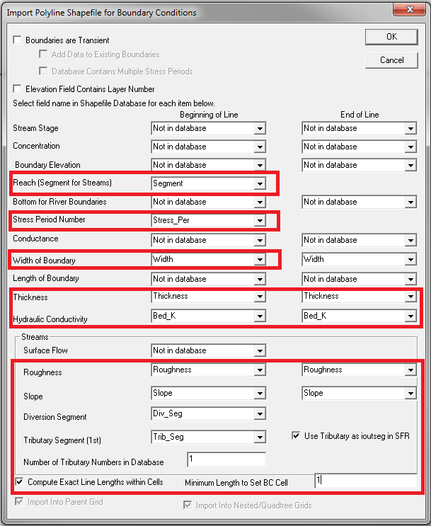First let’s try adding **SFR_Reaches.shp**. Select **BCs🡪Stream**, then **BCs🡪Import🡪Shapefile…** and enter the data into the fields as shown below. Make sure you check the boxes at the bottom for **Compute Exact Line Lengths Within Cells** and **Use Tributary as ioutseg in SFR**.

You will notice you have a lot of error messages that pop up saying segments have zero gradient and the ending stage is being decreased by 0.1 to get correct reach numbers, and by a lot I mean 845. Hold down the Enter key and they will eventually go away. Take a look at your reach numbering. Does it make any sense?

For some reason, or maybe it’s a glitch in GWV, the reach numbers come out all screwy if you try and import a shapefile with the individual segments. This is a problem because our **SFR_Reaches.shp** file contains our elevation data. I’ve found a slightly circuitous method of fixing this though that I’ll take you through in the next few steps.

24) Import **SFR_Segments.shp** into GWV. Select **BCs🡪Stream**, then **BCs🡪Import🡪Shapefile…** and enter the data into the fields like you did in the previous step. Make sure you check the boxes at the bottom for **Compute Exact Line Lengths Within Cells** and **Use Tributary as ioutseg in SFR**. You’ll still get a message about the gradient, but only three of them this time. When asked to check numbering select No. Check the stream reach numbering and make sure it makes sense.

25) In ArcMap, export the attribute table for **SFR_Reaches.shp** (open the attribute table, click on **Table Options** in the top left, then **Export…**) as a text file named **SFR_Reach_Data.txt**.

26) In GWV, export the newly imported stream network to a text file as well by selecting **BCs🡪Export🡪Text File…** and give it the name **Model_SFR_Network.txt**.

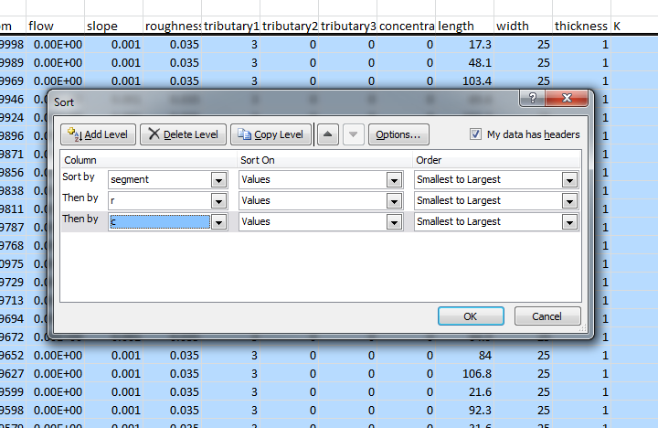27) Open both of these text files in Excel and sort all of the data first by segment, then row, then column

If you count the number of segments exported from GWV you’ll notice that we have fewer reaches than what was exported from ArcMap. This is because when we imported our SFR network into ArcMap, we specified the minimum reach length to be 1 m. This means we need to delete all reaches with a length less than 1 m from **SFR_Reach_Data.txt**. An easy way to do this is to use the Conditional Formatting feature in Excel to highlight the “SLength” column for entries that are less than one. The ordering of segments and reaches should now be identical between the two sheets, so you can copy the elevation (I use Z_Mean) from **SFR_Reach_Data.txt** to the “bottom” columnin **Model_SFR_Network.txt**. While we have the elevation data for each segment in Excel, let’s take a second and plot it to see what it looks like. Below is the elevation profile for Segment 1. Can you see any problem with our extracted elevations? How and/or why do you think this occurred?

Unfortunately, this takes more time than we have to correct but I want you to be aware of it.

25) Now that we have our elevation data added, we can re-import our stream network from the text file. I had you save the elevation data to the text file exported from GWV because it makes it much easier for bringing it back in. First clear the existing stream BCs, then **BCs🡪Import🡪Text File…**

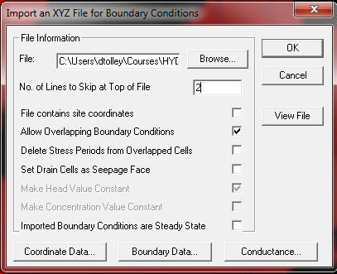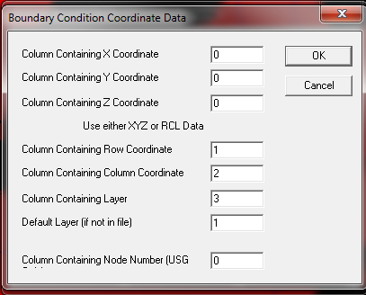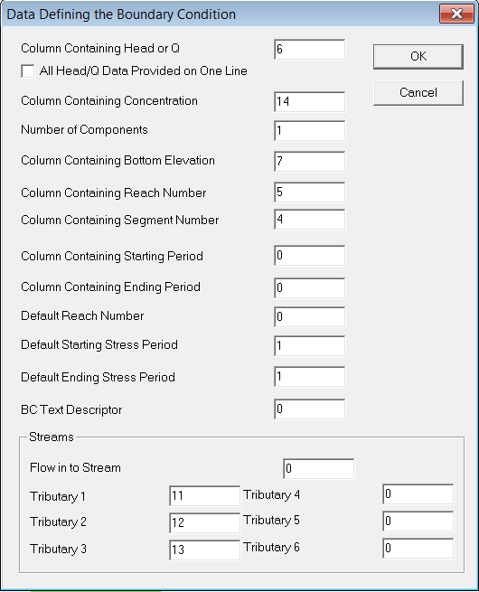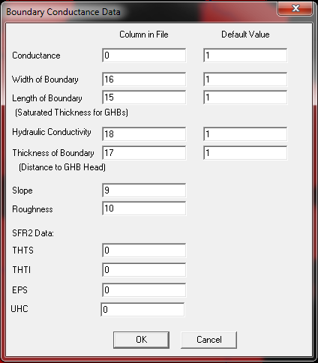

26) We also need to add elevation data to our model. The easiest way to do this that I have found is to convert your DEM raster to a point shapefile using the **Raster to Point** tool (**Conversion Tools🡪From Raster🡪 Raster to Point**). (Note that the rectangle we originally drew to clip the DEM data to extends beyond our model domain. It would be a good idea to clip the data to the model grid polygon to further reduce processing times.) Since we have a fairly detailed DEM, this can take a long time so we aren’t going to do it right now. Once we had our new point shapefile, we would use the **Join Data** function to average all the points that fell within a model cell. To do this, right click on the model grid shapefile exported in step 23 (**Model_Grid**) and select **Joins and Relates🡪Join…** From the dropdown menu at the top, select **Join data from another layer based on spatial location**, then select the new point shapefile you created from the DEM raster. Make sure the first radio button is selected and check the box next to **Average**. Finally, specify your output shapefile in the last field.

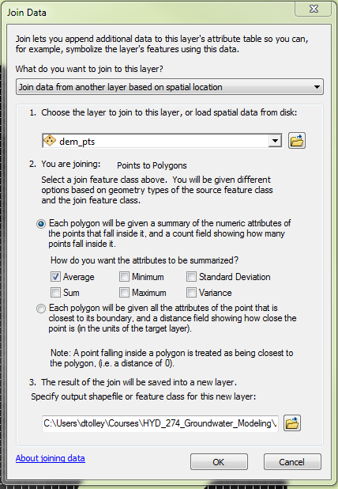

This can also take a very long time to process depending on how big your domain is, so we are not going to do it. However we will look at the results. Add **Model_Grid_w_Elev.shp** to your QGIS project. Do the data make sense?

26) To add the elevation data to our model, Select **Props🡪Top Elevation**, then **Props🡪Import🡪Shapefile…** and add **Model_Grid_w_Elev.shp**. Choose **Avg_GRID_C** in the first dropdown menu then hit ok. Do the data make sense?

27) To make things easy on ourselves, let’s set the bottom elevation of the layer to be equal to 50 meters below the top elevation. If we were really creating a model of this area then we would want to interpolate the bedrock surface using well logs. In fact, I tried to do just that for this lab but unfortunately there are too many areas with sparse data so we end up with large portions of our aquifer that have negative thickness. Doing it correctly would probably take a day or two.

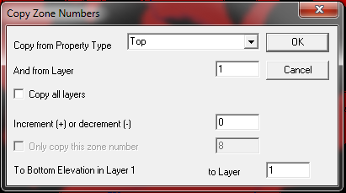Select **Props🡪Bottom Elevation**, then **Props🡪Set Value or Zone🡪Copy…**

Now go to **Props🡪Property Values🡪Math Functions…**

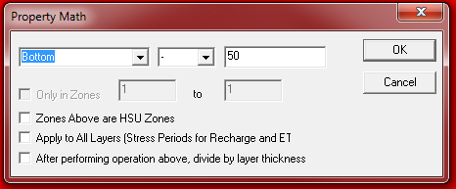

Repeat for the bottom elevation for the second layer, only subtract 100 instead of 50 to make each layer 50 m thick.